SHIVGADHI ENGLISH SCHOOL
Shivraj-1, Kapilvastu
2nd Terminal Examination 2081
Class: 6 (Set- B) F.M. 50
Subject: Science
Attempt all the questions: Group A
- Multiple choice questions. 10
a. How many seconds are there in a day ?
i. 1,24,000 ii. 92,400 iii. 86,400 iv. 64,400
b. Which is an example of modern device ?
i. sickle ii. Refrigerator iii. Plough iv. Basket
c. ………. refers to the physical items associated with a computer system.
i. Hardware ii. Software iii. Firmware iv. Liveware
d. What is the features of omnivores ?
i. Feed on plants ii. Feed on animals
iii. Feed on both plants and animals
iv. Feed on decaying organic matter
e. Which animal is an example of vertebrate?
i. Jackal ii. Earth warm iii. Butterfly iv. Starfish
f. Which group of plants are saprophytes ?
i. Algae ii. Fungi iii. Bryophytes iv. Pteridophytes
g. What is the reproductive organ in flowering plant ?
i. leaf ii. stem iii. Root iv. Flower
h. Which of the following is biotic component ?
i. Air ii. Plant iii. Water iv. Soil
i. What is the SI unit of force ?
i. Newton ii. Kilogram iii. Joule iv. Meter
j. ………… is the force applied to a machine .
i. Effort ii. Load iii. Fulcrum iv. None of these
Group B
Very short answer questions . (8x1=8)
a. What do you mean by rest ?
b. What is simple machine ?
c. What is digestive system?
d. Define Photosynthesis.
e. Give two examples of abiotic components.
f. Define Vertebrates.
g. Write an adaptive organ of fish .
h. What mode of nutrition is found in green plants ?
Group C
Short answer questions . (8x2=16)
a. What is an inclined plane ? Give two examples.
b. Leaf is the kitchen of plant , Justify this statement.
c. What is ecosystem ? List the components of ecosystem.
d. Write differences between herbivores and carnivores.
e. Why are bryophytes called amphibian plants ?
f. Write any two features of animals of class mammalian with examples.
g. List any two things that we have to remember while using computer and smartphone.
h. Convert the following .
i. 2 hours into second ii. 25kg into gram
Group D
Long answer questions ( 4x4=16)
a. What is the force? Write any four effects of force.
b. Describe the photosynthesis process with chemical reaction
and draw a diagram showing photosynthesis process.
c. What is a pulley? Write an application of pulley. Draw a
labeled diagram of pulley .
d. Study the given food web and answer the following questions.
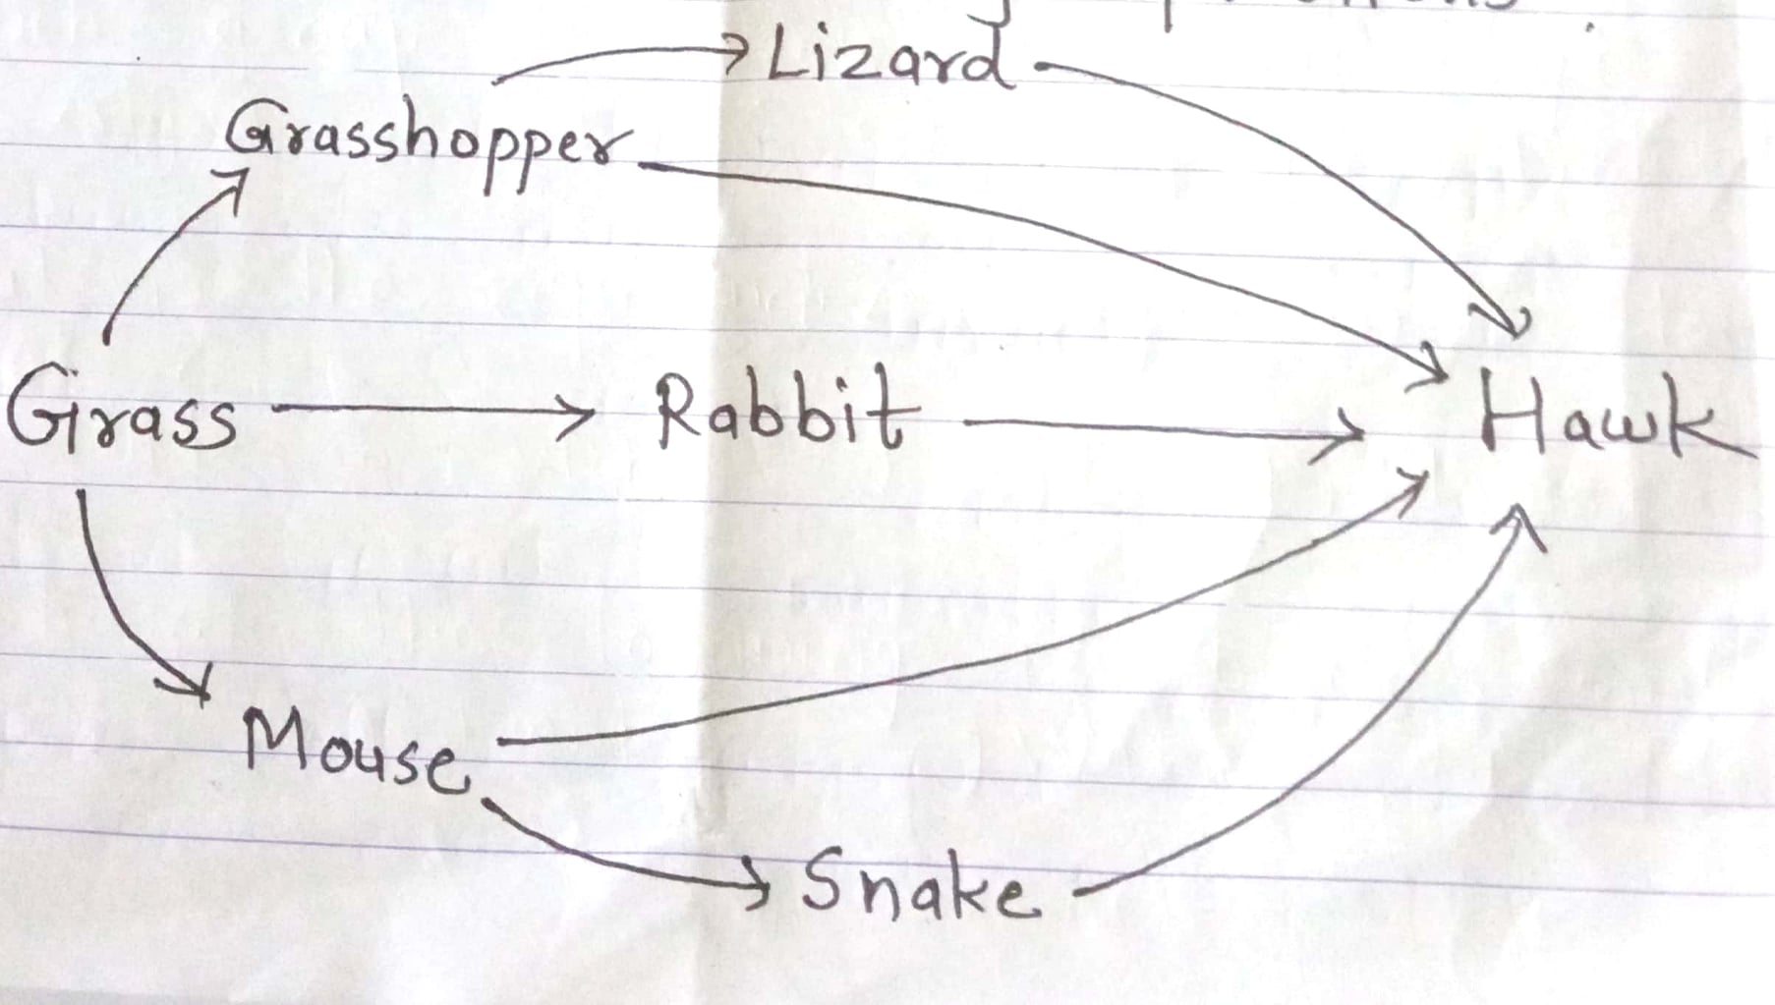

a. Identify secondary consumers.
b. Which one is the top consumer?
c. Why is grass called producer?
d. If the number of rabbits increases excessively, what effect will
be seen on the ecosystem ?
The End

